PO Box 220262
Charlotte, NC 28211-0262
Phone: 1.877.LIBTAYO (1.877.542.8296) Option 1
Fax: 1.833.853.8362
LIBTAYOSurround.com

Sample letter of medical exception

This letter provides an example of the types of information that may be required when writing a letter of medical exception for LIBTAYO.

It is important to note that supplying the information listed in this letter does not guarantee the health plan will provide reimbursement for LIBTAYO, and this information is not intended to substitute for or influence the physician’s independent medical judgment. The sample letter is provided for your guidance only.

Some key reminders:
- You may consider including a letter of medical exception if coverage for LIBTAYO is denied because of the
health plan’s policy or if LIBTAYO is subject to a National Drug Code block
- Be sure to populate an appropriate ICD-10-CM code matching your patient’s diagnosis

Some health plans require a medical exception letter along with supporting documentation,* such as:
- Patient medical records
- Supporting clinical studies
- Patient photographs
- Letter of medical necessity

ICD-10-CM, International Classification of Diseases, Tenth Revision, Clinical Modification.
*To avoid any delays in reimbursement, it is recommended to provide as much documentation as possible.

Please click here for full Prescribing Information.

For any questions or concerns, please contact us at 1.877.LIBTAYO (1.877.542.8296) Option 1, Monday–Friday,
8 am–8 pm Eastern time.
For Colorado Prescribers - Click Here for Pricing Information
For Connecticut Prescribers - Click Here for Pricing Information

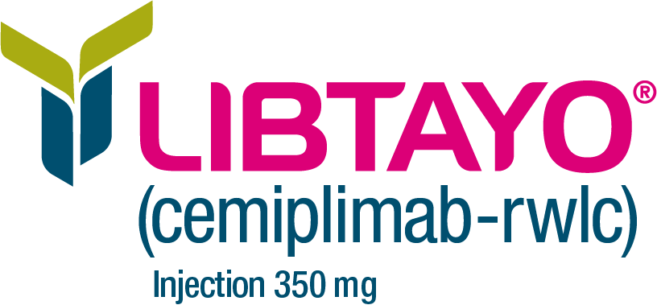
© 2023 Regeneron Pharmaceuticals, Inc. All rights reserved.
US.LIB.23.10.0033 11/23
Sample letter of medical exception

[Use physician’s letterhead]
[Date]

[Health Plan Contact Name]
[Title]
[Health Plan Organization Name]
[Address]
[City, State ZIP]
Re: [Patient Name], Insurance Policy ID Number: [Policy ID Number], Group Number: [Group Number], Claim Number: [Claim Number]

Dear [Health Plan Contact Name],

I am writing to request a medical exception for [Patient full name] for the treatment of [diagnosis] with LIBTAYO® (cemiplimab-rwlc). It is my professional opinion that LIBTAYO is medically appropriate and necessary and should be covered and reimbursed for this patient.
[Patient full name] has been under my care for [insert diagnosis] since [date of onset/diagnosis]. Included for your consideration is [Patient first name]’s medical history and diagnosis (ICD-10-CM code: [insert code]), a statement summarizing my reasons for treating [Patient full name] with LIBTAYO, and a copy of the Prescribing Information for LIBTAYO.

[Insert summary of patient history, including treatment history, response to past therapies, and recent symptoms and conditions.]

In summary, it is my professional judgment that it is in the best interest of [Patient full name] to be treated with LIBTAYO, and I am requesting approval for treatment with LIBTAYO. Please call me at [phone number] if I can be of further assistance or if you require additional information.
Sincerely,

[Physician’s name, degree(s), and signature]
Enclosures: [Attach any additional documentation, as appropriate]

