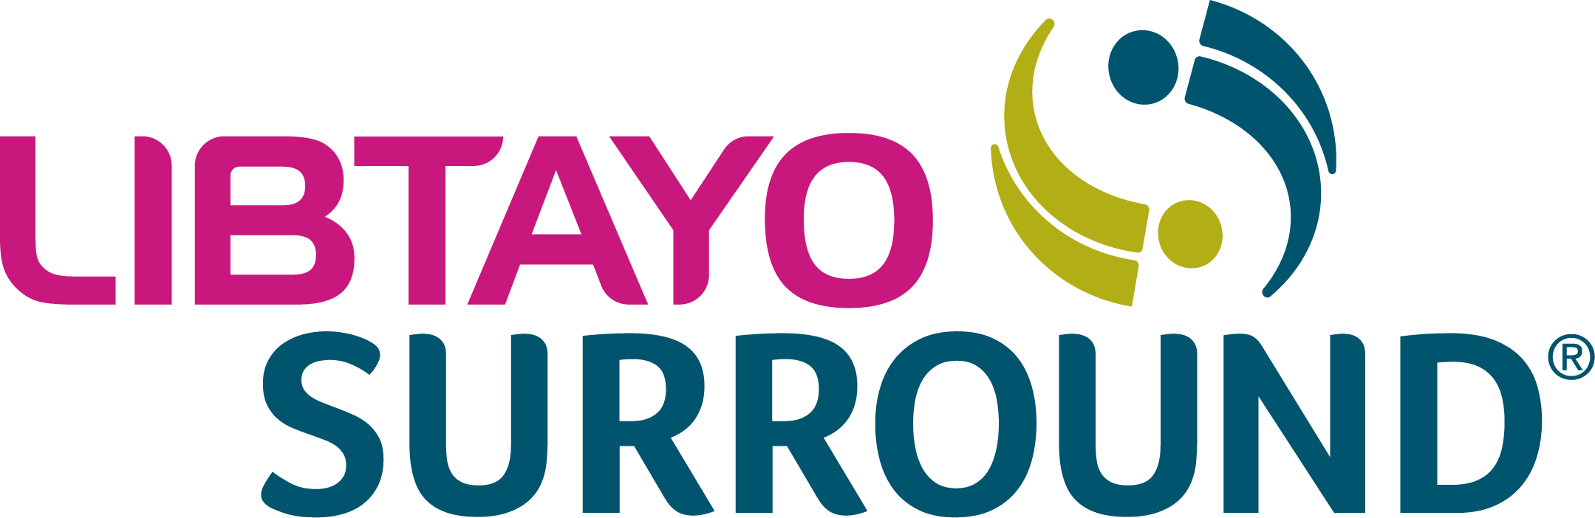
PO Box 220262
Charlotte, NC 28211-0262
Phone: 1.877.LIBTAYO (1.877.542.8296) Option 1
Fax: 1.833.853.8362
LIBTAYOSurround.com

Sample letter of medical necessity
You can use this sample letter of medical necessity to provide the reasons that, in your clinical judgment, LIBTAYO is necessary for your patient. The letter should explain why LIBTAYO is being requested and give health plans additional information they can use to assess whether the medication is approvable.
Please note that providing such a letter does not guarantee the health plan will offer reimbursement for LIBTAYO, and the information is not intended to substitute for or influence the physician’s independent medical judgment. The sample letter is provided for your guidance only.
Some key reminders:
- You may consider including a letter of medical necessity like this one with your PA request to emphasize the medical necessity for LIBTAYO or in addition to your appeal letter, as needed
- Letters of medical necessity should be signed by the physician only
- Be sure to populate an appropriate ICD-10-CM code matching your patient’s diagnosis
Some health plans require a letter of medical necessity along with supporting documentation,* such as:
- Patient’s medical records
- Peer-reviewed literature
- Supporting clinical studies
- Prescribing Information for LIBTAYO
- Clinic notes and laboratory results
ICD-10-CM, International Classification of Diseases, Tenth Revision, Clinical Modification; PA, prior authorization.
*To avoid any delays in reimbursement, it is recommended to provide as much documentation as possible.

Please click here for full Prescribing Information.

For any questions or concerns, please contact us at 1.877.LIBTAYO (1.877.542.8296) Option 1, Monday–Friday,
8 am–8 pm Eastern time.
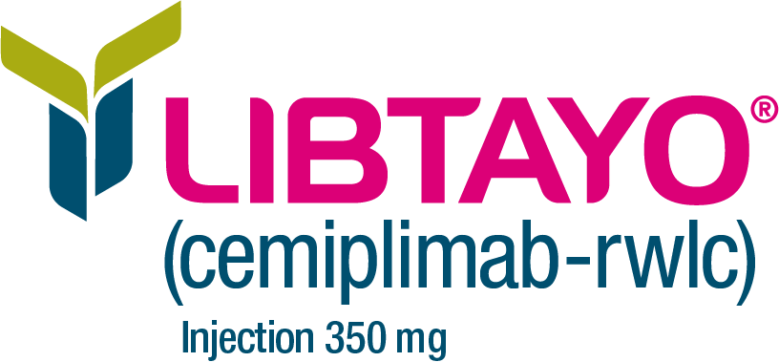
For Colorado Prescribers - Click Here for Pricing Information
For Connecticut Prescribers - Click Here for Pricing Information

© 2023 Regeneron Pharmaceuticals, Inc. All rights reserved.
US.LIB.23.10.0032 11/23

Sample letter of medical necessity

[Use physician’s letterhead]
[Date]

[Health Plan Contact Name]
[Title]
[Health Plan Organization Name]
[Address]
[City, State ZIP]
Re: [Patient Name], Insurance Policy ID Number: [Policy ID Number], Group Number: [Group Number]

Dear [Health Plan Contact Name],

I am writing on behalf of my patient, [Patient full name], to document the medical necessity of LIBTAYO®
(cemiplimab-rwlc). Included below is additional information about the patient’s medical history and diagnosis, as well as a statement summarizing my treatment rationale.

[Include a detailed overview of the patient’s condition and specific diagnosis. Include the patient’s history related to the condition and the length of time you think the patient will need to take the medication.]

In summary, LIBTAYO is medically necessary for this patient’s medical condition, and [health plan name] should cover this product for my patient without delay. Please contact me at [phone number] if additional information is required to ensure prompt approval of this course of treatment.
Sincerely,

[Physician’s name, degree(s), and signature]
Enclosures: [Attach any additional documentation, as appropriate]

